WATERLINEGET…

Outer page cover (designed by badal)

Introduction and note to parents/students

Antonio Fernandes, the founder of waterline started his musical career in bombay where he founded …
To begin with WATERLINE started in the year 2000 in Bombay (Mumbai) it started as a bud now it’s looking forward to an oak tree as the saying goes SKY IS THE LIMIT and now we once again on, on a big venture the founder Antonio Fernando say

[ what are we doing here ]

In this book, we

Index (contents)

History of the grand piano
The piano is a musical instrument played by means of a keyboard that produces sound by striking steel strings with felt covered hammers. The hammers immediately rebound allowing the strings to continue vibrating at their resonant frequency.^{[1]} These vibrations are transmitted through a bridge to a soundboard that amplifies them.
The piano is widely used in Western music for solo performance, ensemble use, chamber music, and accompaniment. It is also very popular as an aid to composing and rehearsal. Although not portable and often expensive, the piano's versatility and ubiquity have made it one of the most familiar musical instruments. It is sometimes classified as both a percussion and a stringed instrument. According to the Hornbostel-Sachs method of music classification, it is grouped with Chordophones.
The word piano is a shortened form of the word pianoforte, which is seldom used except in formal language and derived from the original Italian name for the instrument, clavicembalo [or gravicembalo] col piano e forte (literally harpsichord with soft and loud). This refers to the instrument's responsiveness to keyboard touch, which allows the pianist to produce notes at different dynamic levels by controlling the speed with which the hammers hit the strings.

http://en.wikipedia.org/wiki/Grand_piano

Discipline
- dedication and loyalty
- practice
- posture
- stool height and piano height

what is music?

1)

2)

3)

Q) what is music?

Music Is the fusion of sounds pleasing to the ear and satisfying the soul.

Q) how many notes are there in music?

There are 8 notes in music. While you hear or sing them, there are dytonic notes as well that make a complete set of scales and one octave. There are 7 notes when you read.

Staff reading and musical notation
List all signs and symbols
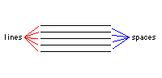 Music is written with the help of 5 lines called the stave or staff. Notes are written above, below, on and in between these 5 lines.

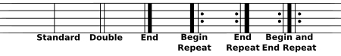
List treble cleff & base cleff
the treble cleff or G cleff is used only for reading right hand notes. It usually plays octaves 3,4,5.

the base cleff or F cleff or C cleff is used for reading left hand notes. It usually plays octaves 1 and 2.

Time signature only 4/4 and ¾

A musical note has a head and a stem. The stem can either point upward or downward. It points upward for notes below the 3rd line in the stave and downward for notes above the 3rd line in the octave. A note indicates both the (note) to be played as well as the duration for which it is to be played.

Notes and rests full, half and quarter
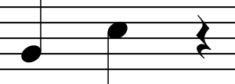
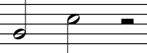

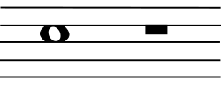
Exercises with notes and rests and time signs.

Finger diagram with names and numbers

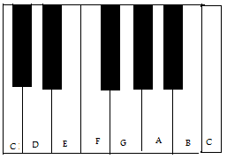
English | C | D | E | F | G | A | B | C
Spanish | Do | Re | Mi | Fa | So | La | Ti | Do
Hindi | Sa | Re | Ga | Ma | Pa | Dha | Ni | Sa

Scales
C | C | D | E | F | G | A | B | C
C# | C# | D# | F | F# | Ab | Bb | C | C#
D | D | E | F# | G | A | B | C# | D
Eb | D# | F | G | G# | A# | C | D | D#
E | E | F# | G# | A | B | C# | D# | E
F | F | G | A | A# | C | D | E | F
F# | F# | G# | A# | B | C# | D# | F | F#
G | G | A | B | C | D | E | F# | G
Ab | G# | A# | C | C# | D# | F | G | G#
A | A | B | C# | D | E | F# | G# | A
Bb | A# | C | D | D# | F | G | A | A#
B | B | C# | D# | E | F# | G# | A# | B

Chords

Playing exercise and finger position

Cccc dddd eeee
Ccc ddd eee fff
Cc dd ee ff
Cdef
Cde def efg fga
Cdecd defde
Cdece defdf
Cdedc defed
Cdecde defdef
Cdede defef

Exercises with rh, lh and then both hands.
Notation also has to be there
Kindergarten songs maintaining 4/4 count
  - mary had a little lamb
  - jack and jill
  - yankee doodle
  - this old man
  - row row row your boat
  - Michael row the boat ashore
  - old mac Donald
  - humpty dumpty
  - hot cross buns
  - one two three four five

- each song separately in different voices
- each song played using 1 hand and 2 hands ( same note, 1st harmony and 2nd harmony )
- each song .

test

correct the following song.

write the names of the foll notes.
- write the following song for the lh (harmony).
Notes and questions.

Contact info for questions, ideas, queries etc..

glossary

